**Project:** AI-Powered HR & Employee Management Bot

**1. Salesforce Edition**

* **Path: Setup → Company Information**
* **Check Organization Edition → Ensure it’s Enterprise Edition.**
  + **Enterprise required for: Automation (Flows), APIs (bot integration), Experience Cloud (employee/manager access), and Sandboxes.**
* **⚠️ If not Enterprise → upgrade.**

**2. Company Profile Setup**

**Path: Setup → Company Information → Edit**

* **Organization Name: AI-Powered HR & Employee Management Bot**
* **Primary Contact: HR IT lead**
* **Default Time Zone: GMT+05:30 Asia/Kolkata**
* **Default Locale: English (India)**
* **Default Language: English**
* **Corporate Currency: INR (Multi-Currency).**

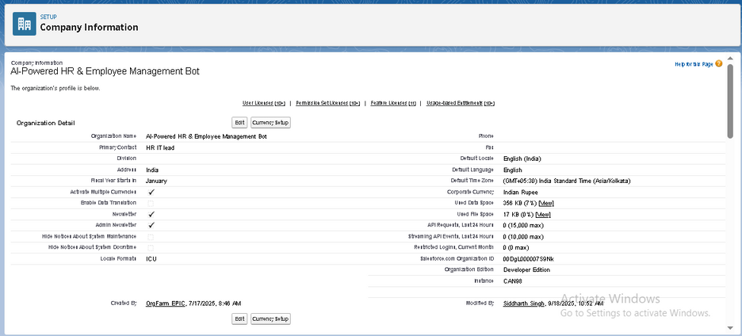

**3. Business Hours & Holidays**

**Business Hours**

* **Path: Setup → Business Hours → New**
* **Name: Standard HR Hours**
* **Time Zone: Asia/Kolkata (GMT+05:30)**
* **Hours: Mon–Fri → 9:00 AM – 6:00 PM, Sat-Sun closed**
* **Save & set as Default Business Hours.**

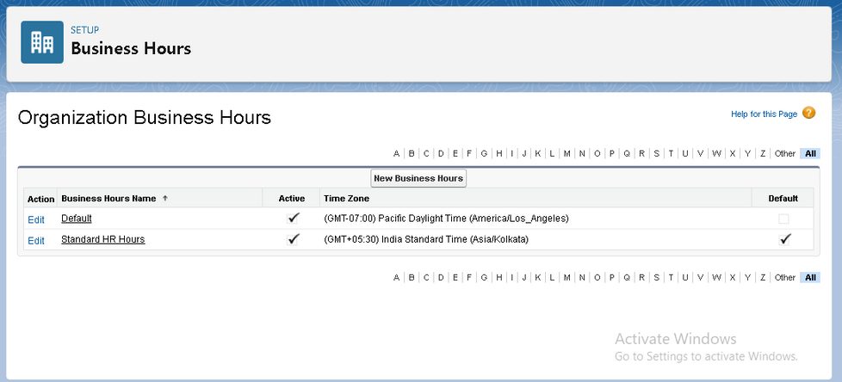

**Holidays**

* **Path: Setup → Holidays → New**
* **Holiday Name: Weekly Off (Sat & Sun)**
* **Description: HR office closed weekends**
* **Dates: Recurring → Saturday & Sunday**
* **Mark “All Day” → ✅**

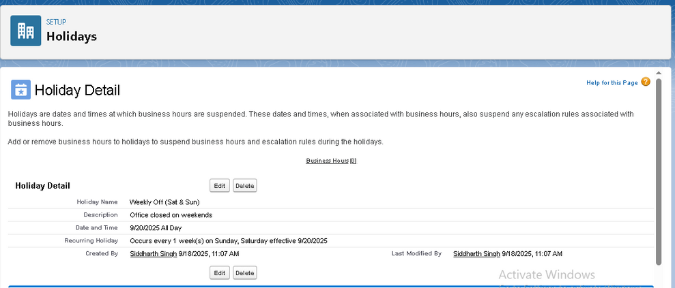

**4. Fiscal Year Settings**

* **Path: Setup → Fiscal Year**
* **Standard Fiscal Year → Apr–Mar (common in HR/payroll compliance for India).**
* **Save.   
   ⚠️ Don’t enable Custom Fiscal Year unless finance/HR specifically requires.**

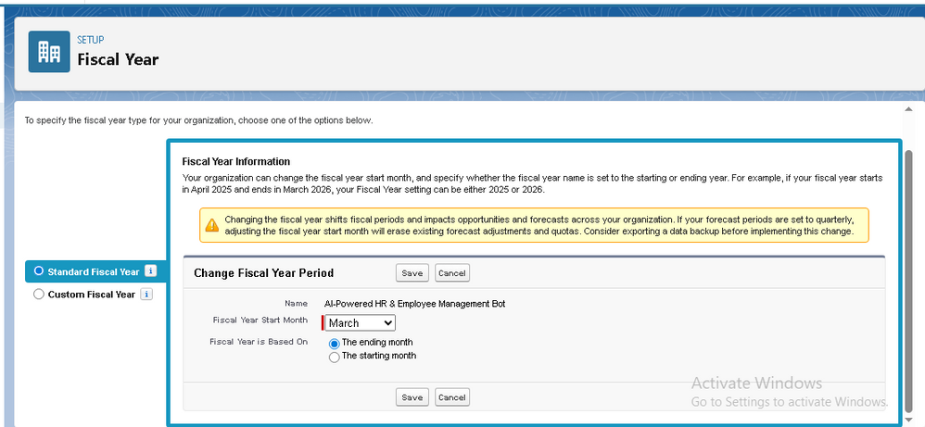

**5. User Setup & Licenses**

**Path: Setup → Users → Users → New User   
 Create sample HR users:**

1. **hrmanager1@aibot.com → Salesforce License → Profile: HR_Manager_Profile → Role: HR Manager**
2. **employee1@aibot.com → Salesforce Platform License → Profile: Employee_Profiles→ Role: Employee**
3. **linelead1@aibot.com → Salesforce License → Profile: Manager_Profile → Role: Line Manager**
4. **botintegration@aibot.com → Salesforce Platform License → Profile: Integration_Profile → Role: System Integration**

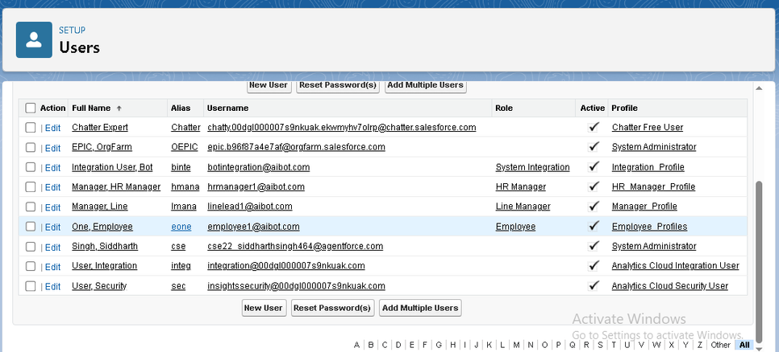

**6. Profiles, Roles & Permission Sets**

**Profiles (baseline access)**

* **Path: Setup → Profiles → New Profile (Clone “Standard User”)**
* **Create:**
  + **HR_Manager_Profile → Full CRUD on Employee, Leave, Attendance, Onboarding, Performance objects**
  + **Manager_Profile → Read/write on direct-report records, Approve/Reject requests**
  + **Employee_Profile → Limited → Can view/update own profile, submit leave/queries**
  + **Integration_Profile → API access only for bot**

**Roles (hierarchy)   
 Path: Setup → Roles → Set Up Roles**

* **CEO**
  + **System Integration**
  + **VP_HR**
    - **HR_Manager**
      * **Line_Manager**
        + **Employee**

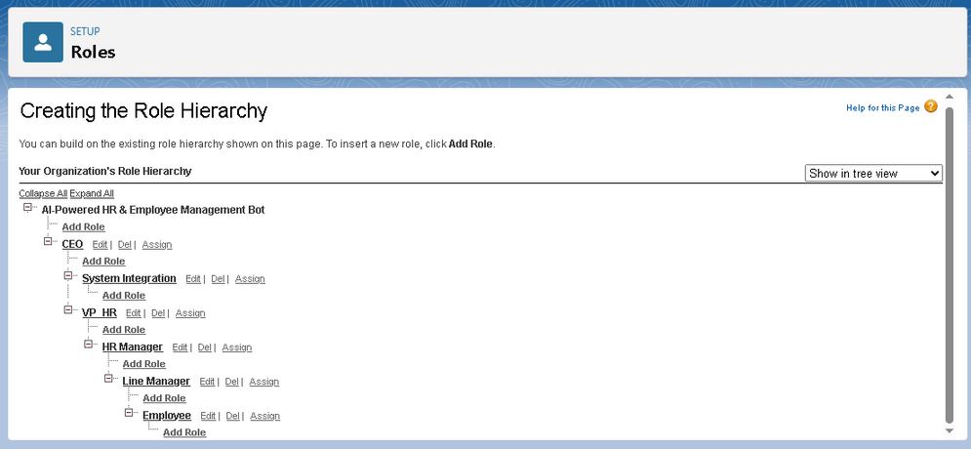

**Permission Sets (exception access)   
 Path: Setup → Permission Sets → New**

* **Create Performance_Access_PS → add object permissions for Performance Review (Read/Edit).**
* **Assign to HR Managers only.**
* **Create Bot_Integration_PS → API Enabled + access to Employee/Attendance/Leave objects.**

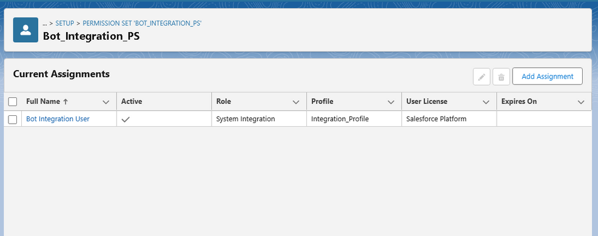

**7. Org-Wide Defaults (OWD) & Sharing Rules**

**👉 Do this once HR objects are created (Phase 3).**

* **Path: Setup → Sharing Settings**
  + **Employees, Leave, Attendance, Performance → Private**

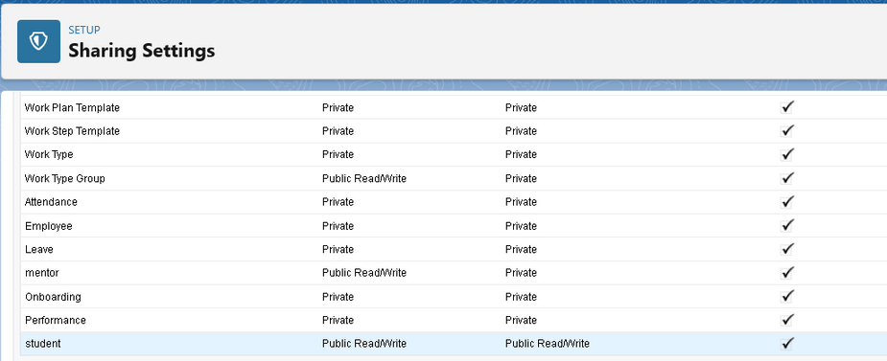

* **Sharing Rules:**
  + **Manager → access to subordinates’ records.**

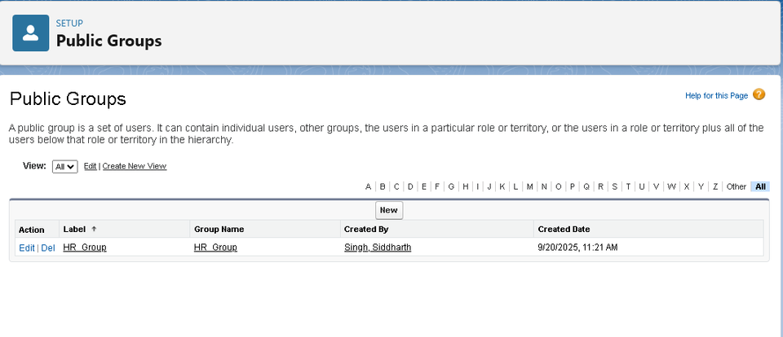

* + **HR → access to all employee records.**

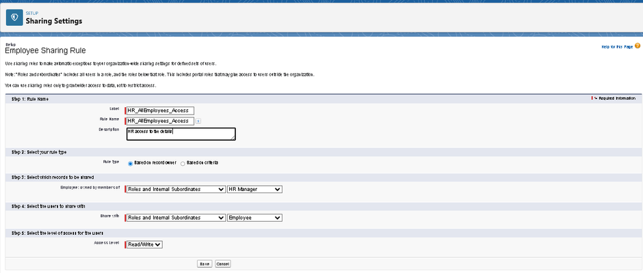

* + **Employees → only their own records.**

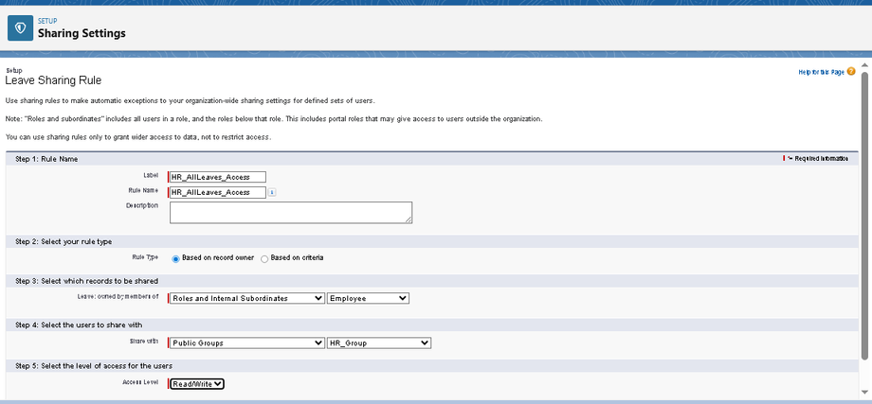

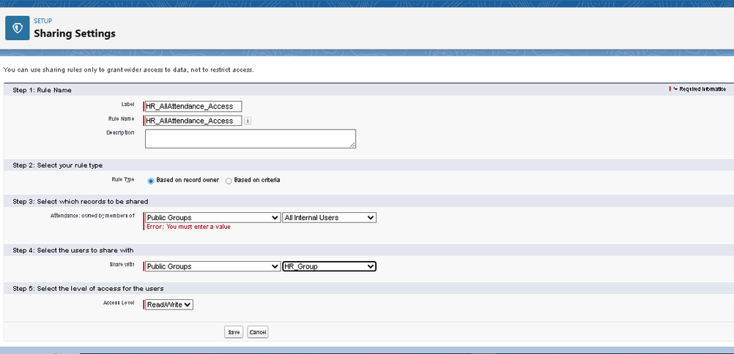

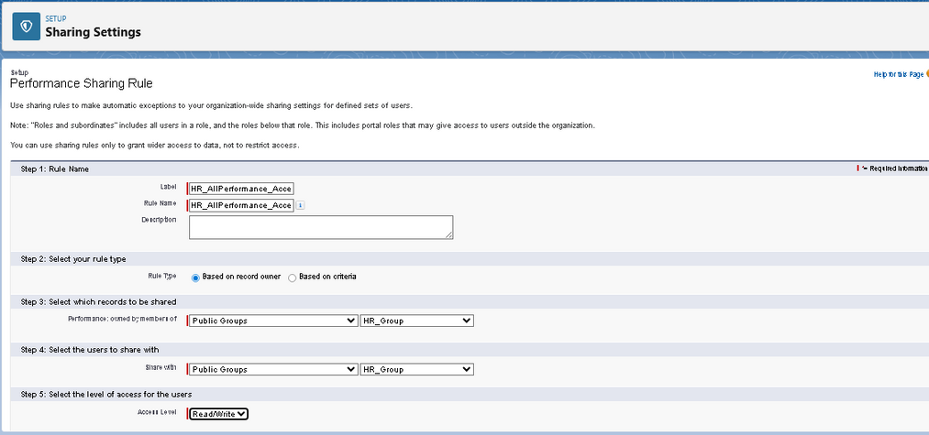

**8. Login Access Policies**

* **Path: Setup → Security → Login Access Policies**
  + **Allow users to grant login access to Admin (for troubleshooting).**
* **Path: Setup → Session Settings**
  + **Session Timeout: 30 minutes**
  + **Lockout: after 3 failed attempts**

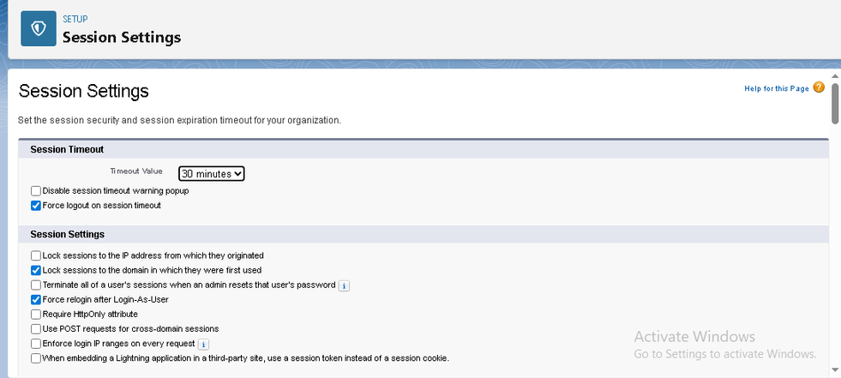

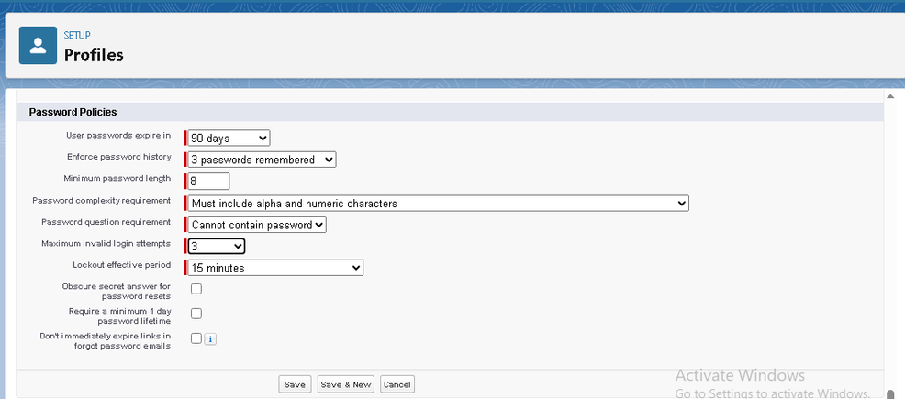

* **Path: Setup → Identity → MFA**
  + **Require MFA for all HR managers & employees**

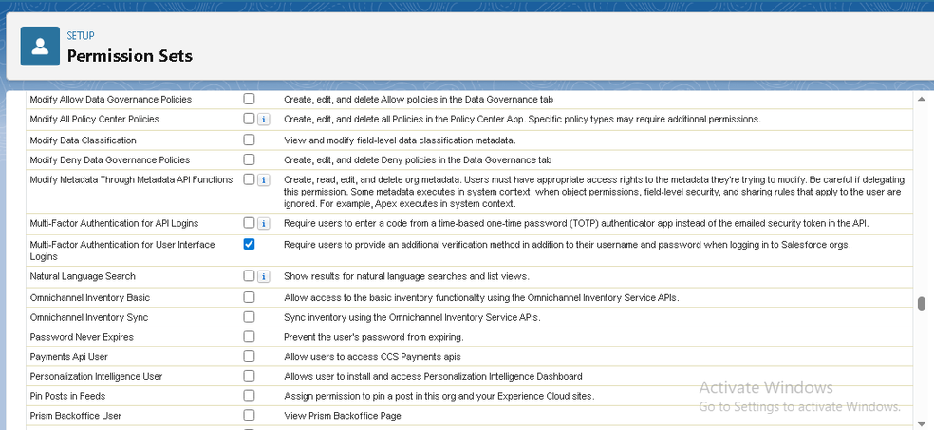

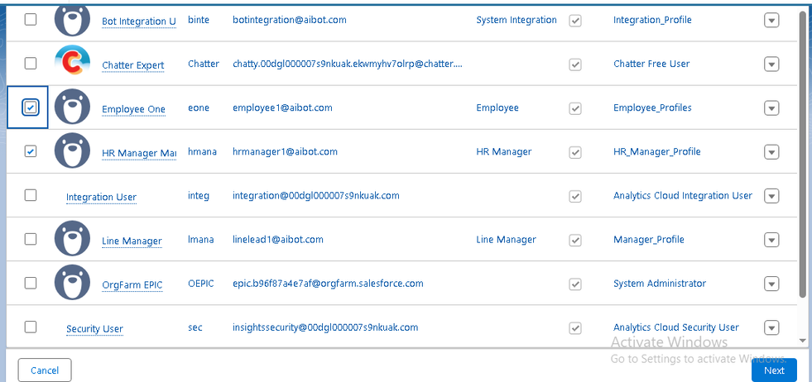

**9. Integration**

* + **Connect VS Code + Salesforce CLI (SF)**
  + **Create GitHub repo for version control (metadata & code)**

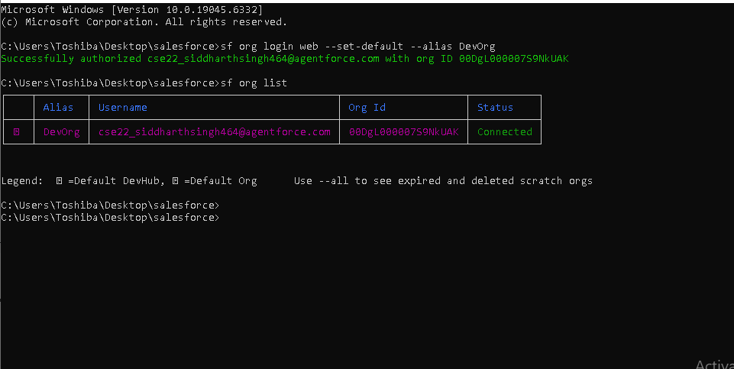

**Quick Summary (HR & Employee Management Bot) :-**

**Profiles: HR Manager, Employee, Team Manager, Admin**

**Roles: CEO → HR Head → HR Manager → Employee; CEO → HR Head → Team Manager → Employee**

**Users: Created for HR, Employees, and Managers**

**OWD: Private (to be finalized in Phase 3)**

**Business Hours: Mon–Fri 9am–6pm, Sat–Sun closed**

**Holidays: Weekly recurring Saturday & Sunday off + Configurable regional holidays**

**Security: MFA + Session control + Optional SSO + Role-based access**